**Case Study 1**

**VLANS, VTP and Inter-Vlan routing**



This covers the competencies 1.1-1.4, 2.1-2.2,2.4-2.5 of ICTNWK 604 and ­for ICTPMG608.

Part of the case study will be done individually. The other part will be done as a group. The report is to be submitted individually

**Scenario**

Your team has been assigned the task of designing the International Travel Agency switched network as shown in the diagram. The steps are described below.

1. Prepare for system implementation.

This will involve coming up a tentative design based on a design brief given to you. This can be done on a design software such as a packet tracer.

Identify implementation options and constraints and select a preferred options and constraints and select a preferred approach in consultation with the clients

Create the system user documentation and get it approved.

1. Manage acceptance testing and collate all the results
2. Manage user training

Undertake training needs analysis

1. Release new system

Create a rollback strategy and plan to guide rollback if changes are needed.

**Required Resources**

• 1 router (Cisco 1841 with Cisco IOS Release 12.4(24)T1 Advanced IP Services or comparable or Cisco 2800)

• 2 switches (Cisco 2960 with the Cisco IOS Release 12.2(46)SE C2960-LANBASEK9-M image or comparable)

• 2 switches (Cisco 3560 with the Cisco IOS Release 12.2(46)SE C3560-ADVIPSERVICESK9-mz image or comparable)

• Ethernet and console cables

**Requirements**

1. **Prepare for system implementation**

You will configure a group of switches and a router for the International Travel Agency. The network includes two distribution switches, DLS1 and DLS2, and two access layer switches, ALS1 and ALS2. External router R1 and DLS1 provide inter-VLAN routing. You can subnet it any way you want, although it is recommended to use /24 subnets for simplicity.

Wherever there are two options they should be implemented as separate version of the design.

Design the addressing scheme using the address space 172.16.0.0/16 range **:option 1**

Design the addressing scheme using the address space 150.5.0.0/16 range **:option 2**

1. Disable the links between the access layer switches.

2. Place all switches in the VTP domain CISCO.

a) Make DLS1 the VTP server and all other switches VTP clients. Option 1

b) Make DLS2 the VTP server and all other switches VTP clients. Option 1

3. On DLS1, create the VLANs shown in the VLAN table and assign the names given. For subnet planning, allocate a subnet for each VLAN.

.4. a) Configure DLS1 as the primary spanning-tree root bridge for all VLANs. Configure DLS2 as the backup root bridge for all VLANs. **Option 1**

b) Configure DLS2 as the primary spanning-tree root bridge for all VLANs. Configure DLS1 as the backup root bridge for all VLANs. **Option 2**

5. Configure Fa0/12 between DLS1 and DLS2 as a Layer 3 link and assign a subnet to it.

6. Create a loopback interface on DLS1 and assign a subnet to it.

7. Configure the Fa0/11 link between DLS1 and DLS2 as an ISL trunk.

8. Statically configure all inter-switch links as trunks.

9. Configure all other trunk links using 802.1Q.

10. Bind together the links from DLS1 or DLS2 to each access switch together in an EtherChannel.

**Option 1**. Use DLS1 if it is the primary root

**Option 2**: Use DLS2 if it is the primary root

a) Use PaGP as the protocol**. option 1**

b) Use LACP as protocol : **option 2**

11. Enable PortFast on all access ports.

12. Place Fa0/15 through Fa0/17 on ALS1 and ALS2 in VLAN 10. Place Fa0/18 and Fa0/19 on ALS1 and ALS2 in VLAN 20. Place Fa0/20 on ALS1 and ALS2 in VLAN 30. Place Fa0/21 on ALS1 and ALS2 in VLAN 40.

13. Create an 802.1Q trunk link between R1 and ALS2. Allow only VLANs 10 and 40 to pass through the trunk.

14. Configure R1 subinterfaces for VLANs 10 and 40.

15. Set up a host on port Fa0/15 on ALS1 with an appropriate address. Set up a host on Fa0/21 on ALS2 with an appropriate address. These addresses should be set up with DHCP.

16. Create an SVI on DLS1 in VLANs 20, 30, and 40. Create an SVI on DLS2 in VLAN 10, an SVI on ALS1 in VLAN 30, and an SVI on ALS2 in VLAN 40.

17. Enable IP routing on DLS1. On R1 and DLS1, configure EIGRP for the whole major network and disable automatic summarization.

These two designs can be done on packet tracer and submitted to the client for approval.

The outputs needed for the initial design testing

1. Show VLANs are propagated to client switches
2. Show primary and secondary roots
3. Show ether channel is set up correctly
4. Show connectivity between hosts

Indicate which part of this design you could not do on the design software

1. **Approval of the design**

You have a discussion with the clients who will check your initial design

Modification of the design will be specified during the discussion.

1. **Setting up the new design on real equipment.**

You will set up the equipment with the modified design and conduct acceptance testing.

1. **Acceptance testing**

The following information is needed in the acceptance testing along with explanation.

1. Brief design scheme showing client requirements including subnetting information.
   1. 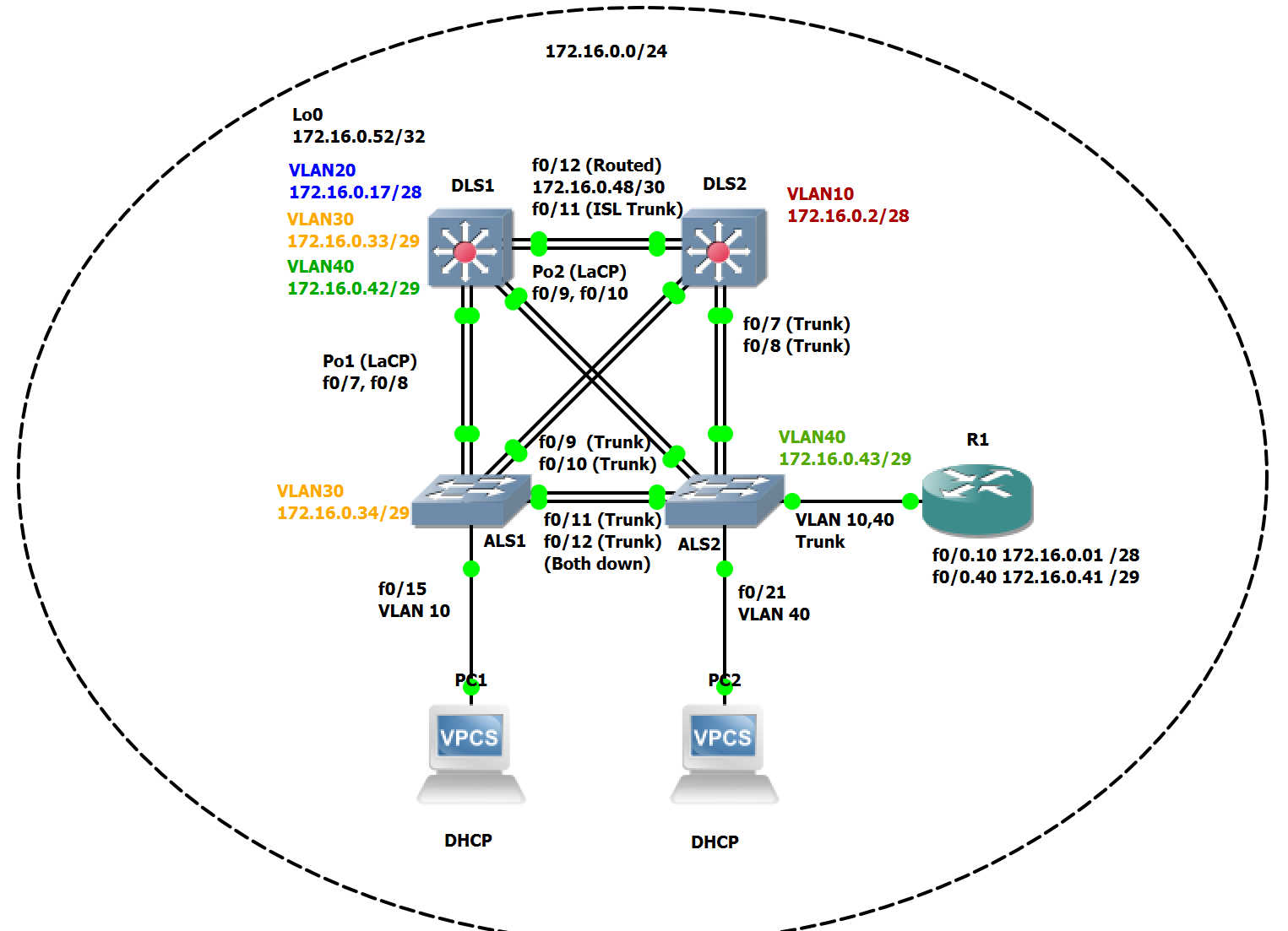
2. VTP scheme adopted. Tests to show VLANs have propagated to all switches.
   1. 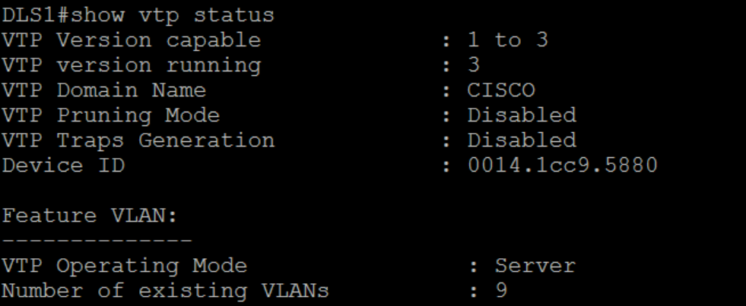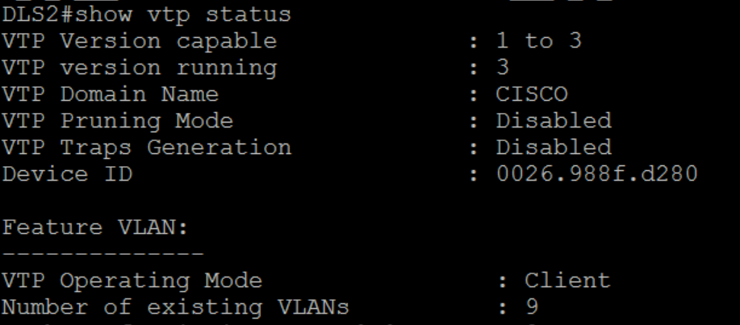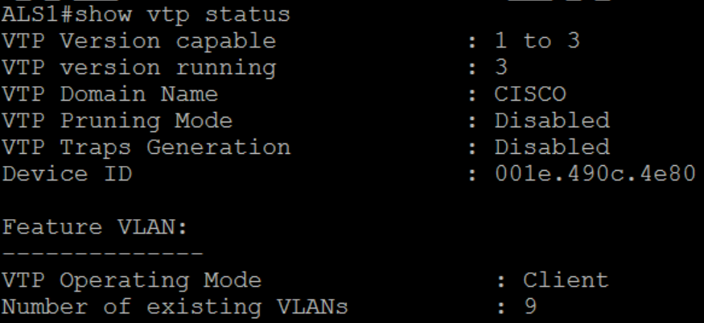

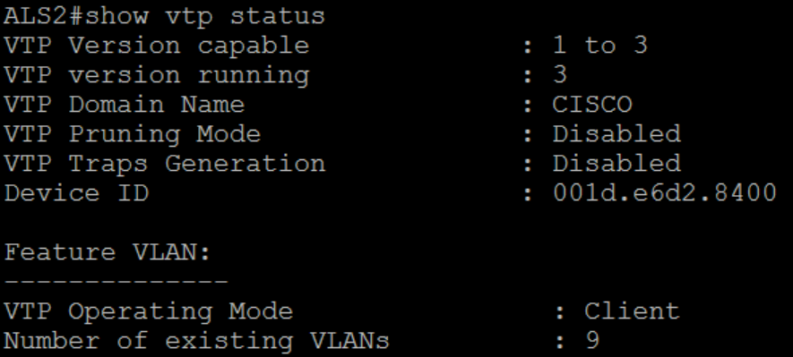

* 1. 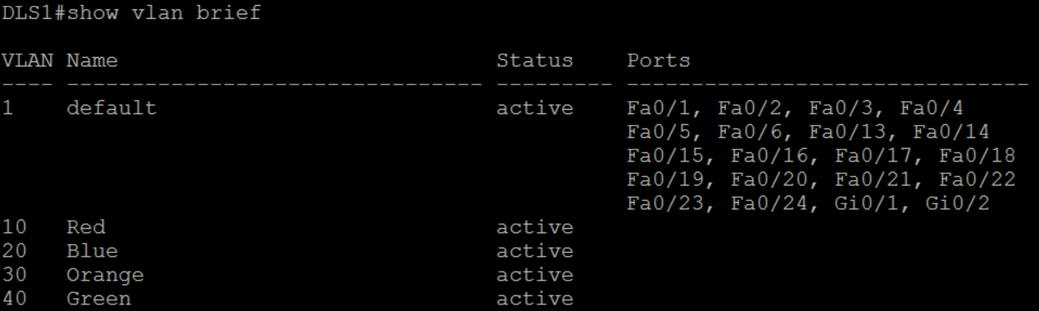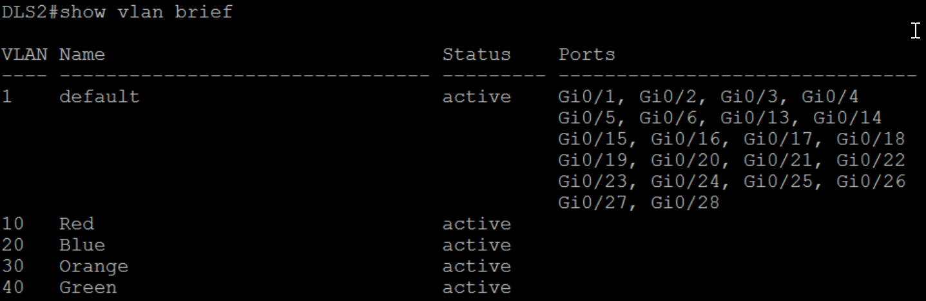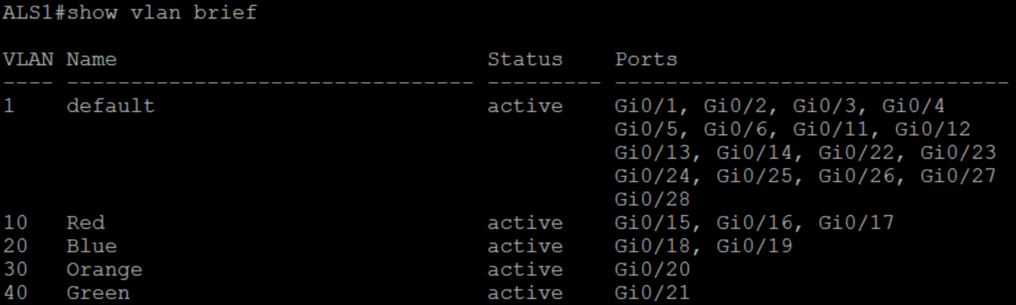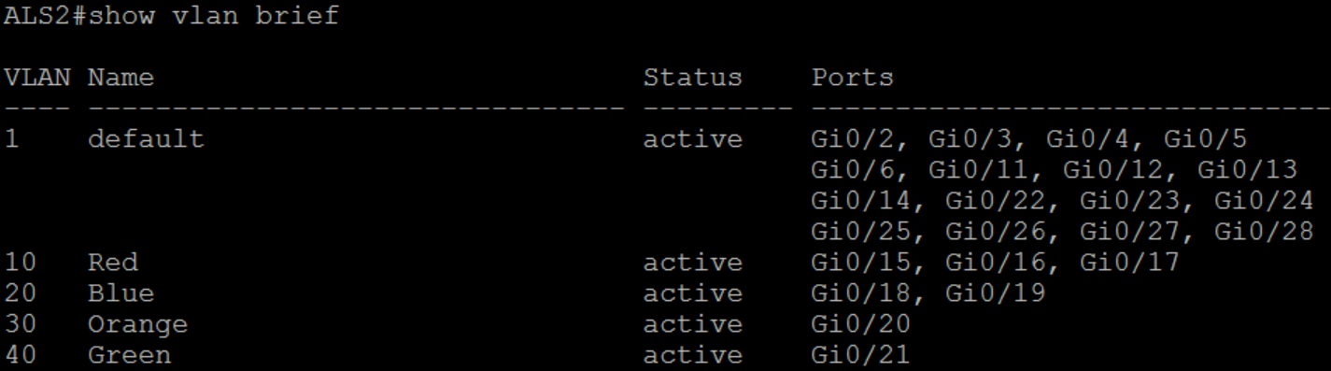

1. Output to show the primary and secondary root of each VLAN
   1. 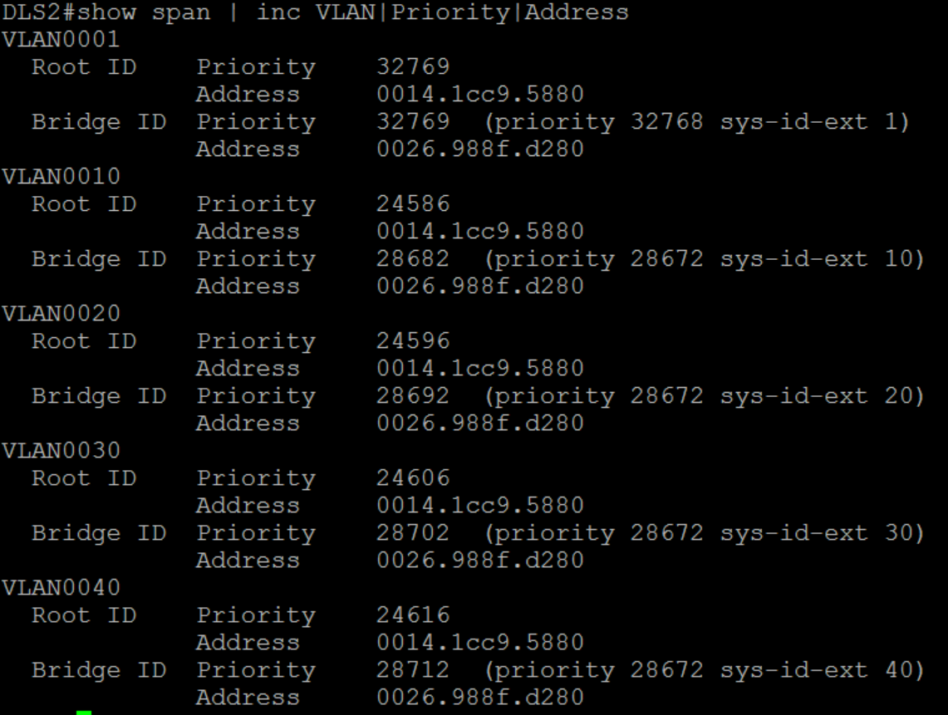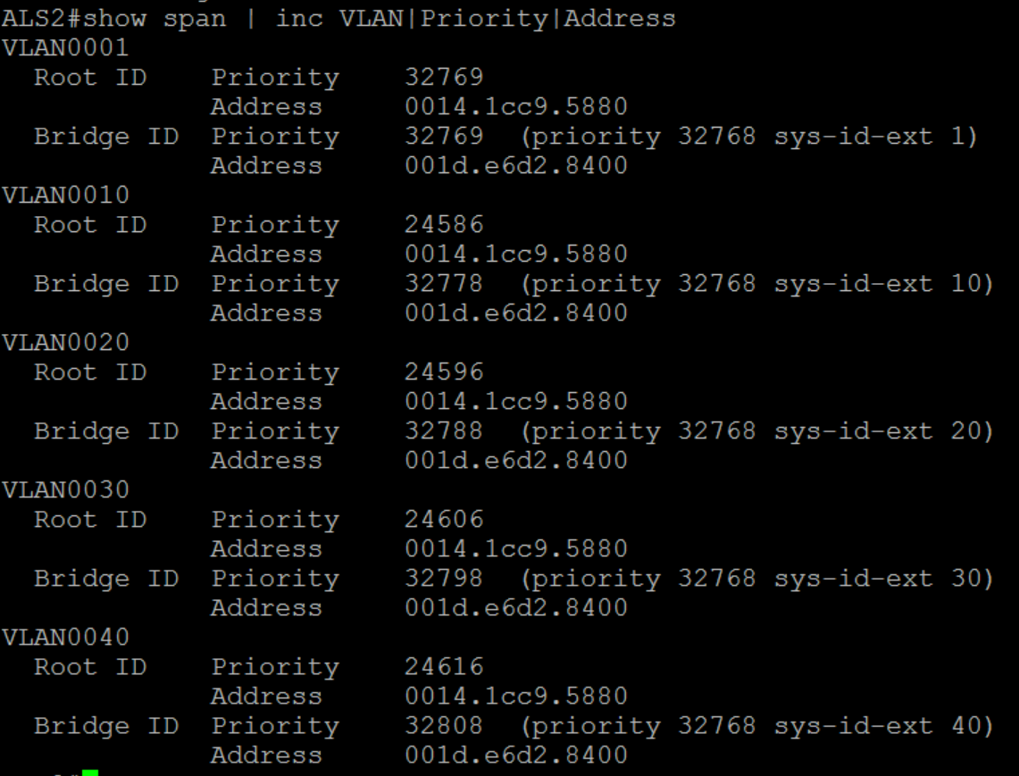
2. Proper setup of trunking.
   1. 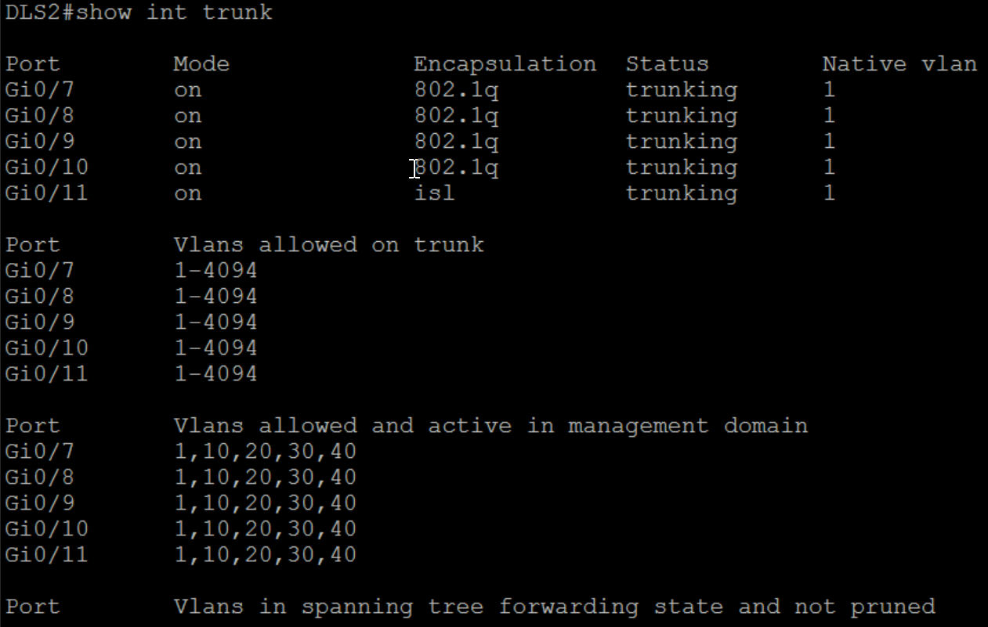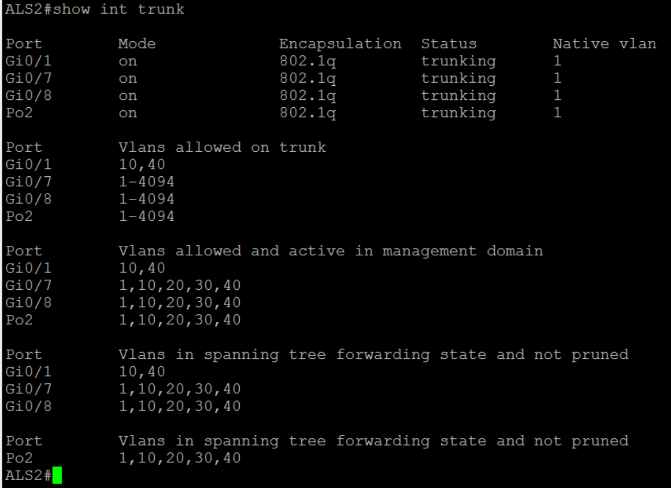
3. Ether channels are correctly set up with the appropriate protocol
   1. 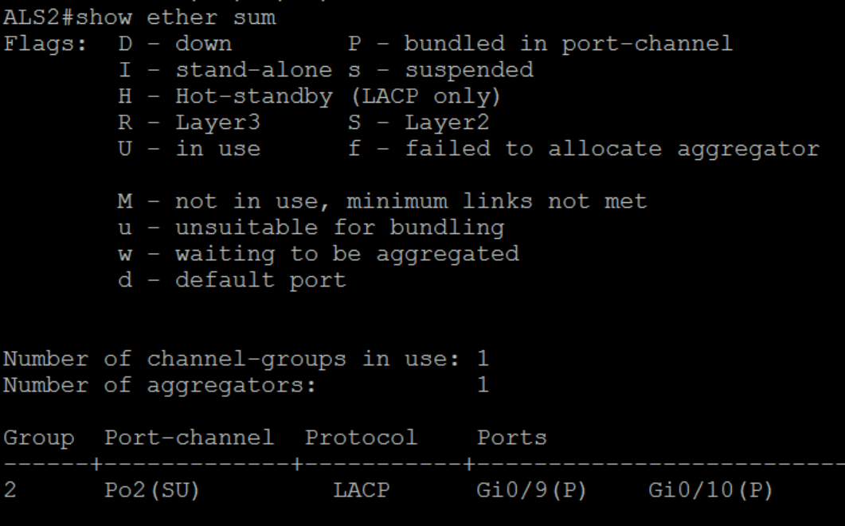
4. Access ports set up with portfast
   1. 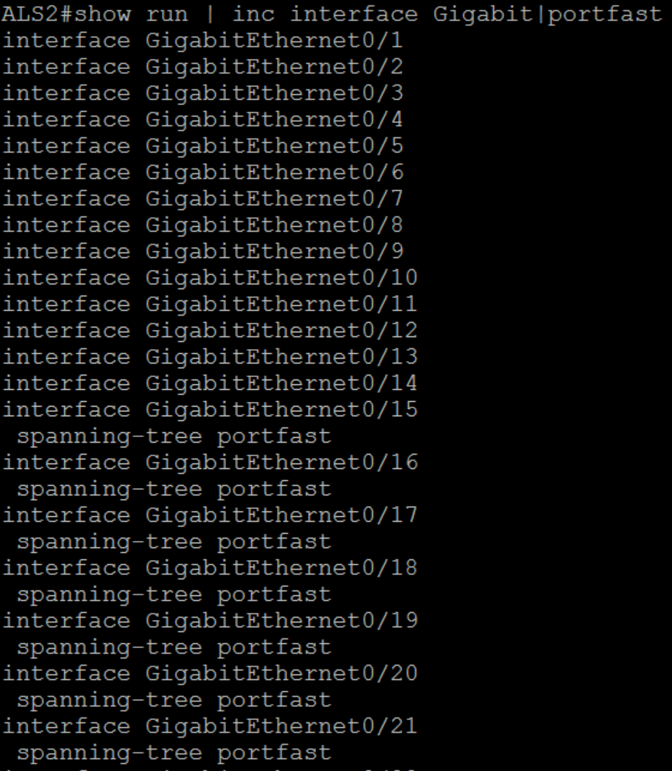
5. Connectivity between access ports on VLAN 10 to VLAN 20,30 and 40. Identify all the subnets in the output of show ip route.

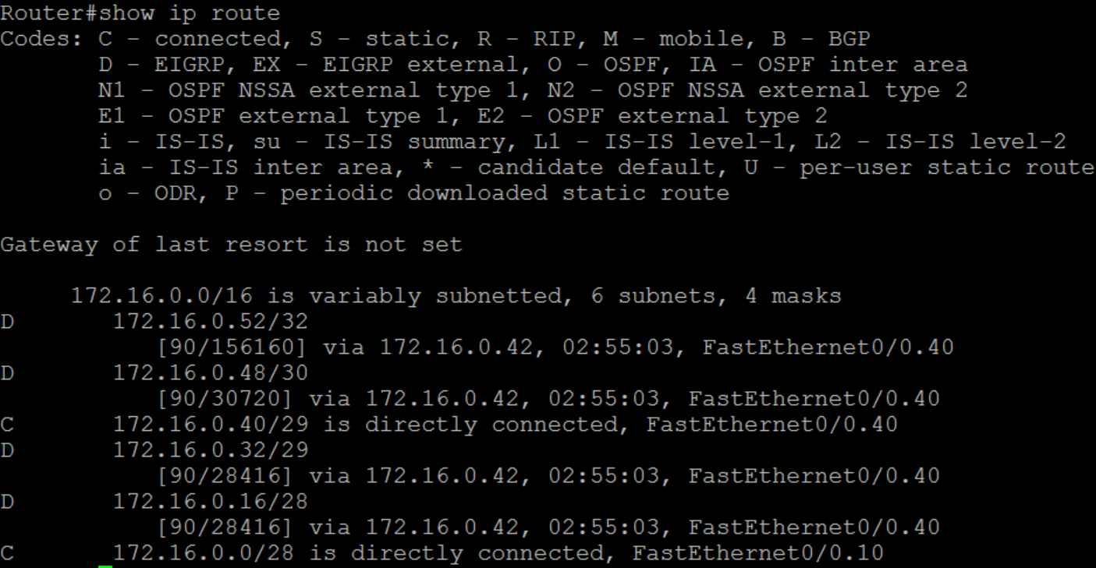

**172.16.0.0/24 is our network (classful /16), with 172.16.0.0/28 being VLAN10 (F0/0.10), 172.16.0.16/28 being VLAN20 (Learnt from EIGRP), 172.16.0.32/29 being VLAN30 (Learnt from EIGRP), 172.16.0.40/29 being VLAN40 (f0/0.40), 172.16.0.48/30 being DLS1<->DLS2 Layer3 link (Learnt from EIGRP) and 172.16.0.52/32 being Loopback0 on DLS1 (Learnt from EIGRP)**

**Deliverables. ( 20 marks)**

1. Short summary of the of the implementation plan including initial design, testing and approval ( 3 marks)
2. Summary of changes suggested in the discussion with the client. ( 3 marks)
   1. The client wanted VTP v3, LaCP as the ether channel negotiation protocol, keep DLS1 as the primary root, with DLS2 as the secondary root. The client also wanted to make sure our subnetting fit in 172.16.0.0/24 compared to the original /16 that was given. Rapid PVST+ needed to be enabled on all devices and DHCP to continue existing.
3. Describe the coordination of the release of the system with the new design. You may also comment on the IOS needed to implement these changes. (2 marks)
   1. IOS 12.2(33) is the minimum version required as that was the first IOS to support VTP v3, and on the trolley setup, 3 of the 4 switches can be on IOS 15.0(1) due to being 3560G’s, though the top switch cannot as it is only a 3560. If it were to be replaced with a 2960 switch, the full setup can be IOS 15.
4. Tests conducted and their results. Comment on these results. ( 3 marks)
5. Release of the new system and any rollback you might suggest. ( 2 marks)
6. Undertake training needs analysis for the client to maintain the system. ( 3 marks)
7. Documentation to be given to the client on the new system. ( 4 marks)